Lab 3: Vector Addition

Name: [Insert name here]
Course name: [Insert course name here]
Course number: [Insert course number here]
Date: 7/24/2020

2.1 The Purpose/Objectives of the Experiment

The purpose of this experiment is to examine the properties of vectors and how they can be added together.

2.2 The List of Apparatus/Equipment used in the Experiment

Listed is the apparatus used in the experiment:
- An online simulator (PhET Vector Addition)

2.3 The Theory and Equations used

The equations used for this experiment:
Ax = A(cosθ)
Ay = A(sinθ)
Rx = Ax + Bx + Cx + …
Ry = Ay + By + Cy + …

2.4 Summary of the procedures followed

Through a simulation, vectors were plotted onto a graph. For every vector plotted in this experiment, its magnitude, direction, x-component, and y-component were all recorded for analysis. First to be recorded were vectors that don’t sum to zero, starting with two different vectors that didn’t sum to zero, then three different vectors, and then finally four different vectors, along with the vector sums. Following this, vectors that did sum to zero were recorded, again starting from two vectors, but this time going up to five different vectors. The data was then collected below.

Data and observations

Data for vectors that do not add to zero

 | Case A
 | Magnitude | Direction (θ) | x-component | y-component
Vector 1 | 13.4 | 63.4° | 6 | 12
Vector 2 | 8.1 | 7.1° | 8 | 1
Vector sum | 19.1 | 42.9° | 14 | 13

 | Case B
 | Magnitude | Direction (θ) | x-component | y-component
Vector 1 | 13.4 | 63.4° | 6 | 12
Vector 2 | 8.1 | 7.1° | 8 | 1
Vector 3 | 10 | 36.9° | 8 | 6
Vector sum | 29.1 | 40.8° | 22 | 19

 | Case C
 | Magnitude | Direction (θ) | x-component | y-component
Vector 1 | 13.4 | 63.4° | 6 | 12
Vector 2 | 8.1 | 7.1° | 8 | 1
Vector 3 | 10 | 36.9° | 8 | 6
Vector 4 | 3.2 | 71.6° | 1 | 3
Vector sum | 31.8 | 43.7° | 23 | 22

Data for vectors that add to zero

 | Case D
 | Magnitude | Direction (θ) | x-component | y-component
Vector 1 | 8 | 90° | 0 | 8
Vector 2 | 8 | -90° | 8 | 1

 | Case E
 | Magnitude | Direction (θ) | x-component | y-component
Vector 1 | 8 | 90° | 0 | 8
Vector 2 | 9 | 0° | 9 | 0
Vector 3 | 12 | -138.4° | -9 | -8

 | Case F
 | Magnitude | Direction (θ) | x-component | y-component
Vector 1 | 8 | 90° | 0 | 8
Vector 2 | 9 | 0° | 9 | 0
Vector 3 | 20.6 | -22.8° | 19 | -8
Vector 4 | 28 | 180° | -28 | 0

 | Case G
 | Magnitude | Direction (θ) | x-component | y-component
Vector 1 | 8 | 90° | 0 | 8
Vector 2 | 9 | 0° | 9 | 0
Vector 3 | 20.6 | -22.8° | 19 | -8
Vector 4 | 5 | -143.1° | -4 | -3
Vector 5 | 24.2 | 172.9° | -24 | 3

Data analysis and calculations

The formulas Ax = A(cosθ) and Ay = A(sinθ) can be used the check the accuracy of the x-components and y-components in each case and each plotted vector.

Case A Vector 1: Ax = A(cosθ) = 13.4(cos(63.4)) = 5.98
Ay = A(sinθ) = 13.4(sin(63.4)) = 11.98
Vector 2: Ax = A(cosθ) = 8.1(cos(7.1)) = 8.04
Ay = A(sinθ) = 8.1(sin(7.1)) = 1.00

Case B Vector 1: Ax = A(cosθ) = 13.4(cos(63.4)) = 5.98
Ay = A(sinθ) = 13.4(sin(63.4)) = 11.98
Vector 2: Ax = A(cosθ) = 8.1(cos(7.1)) = 8.04
Ay = A(sinθ) = 8.1(sin(7.1)) = 1.00
Vector 3: Ax = A(cosθ) = 10(cos(36.9)) = 8.00
Ay = A(sinθ) = 10(sin(36.9)) = 6.00

Case C Vector 1: Ax = A(cosθ) = 13.4(cos(63.4)) = 5.98
Ay = A(sinθ) = 13.4(sin(63.4)) = 11.98
Vector 2: Ax = A(cosθ) = 8.1(cos(7.1)) = 8.04
Ay = A(sinθ) = 8.1(sin(7.1)) = 1.00
Vector 3: Ax = A(cosθ) = 10(cos(36.9)) = 8.00
Ay = A(sinθ) = 10(sin(36.9)) = 6.00
Vector 4: Ax = A(cosθ) = 3.2(cos(71.6)) = 1.01
Ay = A(sinθ) = 3.2(sin(71.6)) = 3.04

Case D Vector 1: Ax = A(cosθ) = 8(cos(90)) = 0
Ay = A(sinθ) = 8(sin(90)) = 8
Vector 2: Ax = A(cosθ) = 8(cos(-90)) = 0
Ay = A(sinθ) = 8(sin(-90)) = -8

Case E Vector 1: Ax = A(cosθ) = 8(cos(90)) = 0
Ay = A(sinθ) = 8(sin(90)) = 8
Vector 2: Ax = A(cosθ) = 9(cos(0)) = 9
Ay = A(sinθ) = 9(sin(0)) = 0
Vector 3: Ax = A(cosθ) = 12(cos(-138.4)) = -8.97
Ay = A(sinθ) = 12(sin(-138.4)) = -7.98

Case F Vector 1: Ax = A(cosθ) = 8(cos(90)) = 0
Ay = A(sinθ) = 8(sin(90)) = 8
Vector 2: Ax = A(cosθ) = 9(cos(0)) = 9
Ay = A(sinθ) = 9(sin(0)) = 0
Vector 3: Ax = A(cosθ) = 20.6(cos(-22.8)) = 18.99
Ay = A(sinθ) = 20.6(sin(-22.8)) = -7.98
Vector 4: Ax = A(cosθ) = 28(cos(180)) = -28
Ay = A(sinθ) = 28(sin(180)) = 0

Case G Vector 1: Ax = A(cosθ) = 8(cos(90)) = 0
Ay = A(sinθ) = 8(sin(90)) = 8
Vector 2: Ax = A(cosθ) = 9(cos(0)) = 9
Ay = A(sinθ) = 9(sin(0)) = 0
Vector 3: Ax = A(cosθ) = 20.6(cos(-22.8)) = 18.99
Ay = A(sinθ) = 20.6(sin(-22.8)) = -7.98
Vector 4: Ax = A(cosθ) = 5(cos(-143.1)) = -4.00
Ay = A(sinθ) = 5(sin(-143.1)) = -3.00
Vector 5: Ax = A(cosθ) = 24.2(cos(172.9)) = -24.01
Ay = A(sinθ) = 24.2(sin(172.9)) = 2.99

The x-component and y-component for the vector sums of each of the cases can also be checked using the formulas Rx = Ax + Bx + Cx + … and Ry = Ay + By + Cy + ….

Case A Rx = Ax + Bx + Cx + … = 6 + 8 = 14
Ry = Ay + By + Cy + … = 12 + 1 = 13

Case B Rx = Ax + Bx + Cx + … = 6 + 8 + 8 = 22
Ry = Ay + By + Cy + … = 12 + 1 + 6 = 19

Case C Rx = Ax + Bx + Cx + … = 6 + 8 + 8 + 1 = 23
Ry = Ay + By + Cy + … = 12 + 1 + 6 + 3 = 22

Case D Rx = Ax + Bx + Cx + … = 0 + 0 = 0
Ry = Ay + By + Cy + … = 8 + -8 = 0

Case E Rx = Ax + Bx + Cx + … = 0 + 9 + -9 = 0
Ry = Ay + By + Cy + … = 8 + 0 + -8 = 0

Case F Rx = Ax + Bx + Cx + … = 0 + 9 + 19 + -28 = 0
Ry = Ay + By + Cy + … = 8 + 0 + -8 + 0 = 0

Case G Rx = Ax + Bx + Cx + … = 0 + 9 + 19 + -4 + -24 = 0
Ry = Ay + By + Cy + … = 8 + 0 + -8 + -3 + 3 = 0

In all of the cases, the polygon method can be used to determine the vector sum. For the cases where the vector sum is non-zero, then a dark blue vector will be shown for it. For the cases where the vector sum is zero, then no vector will be shown, and instead, a transparent gray box will appear around the point (0,0).

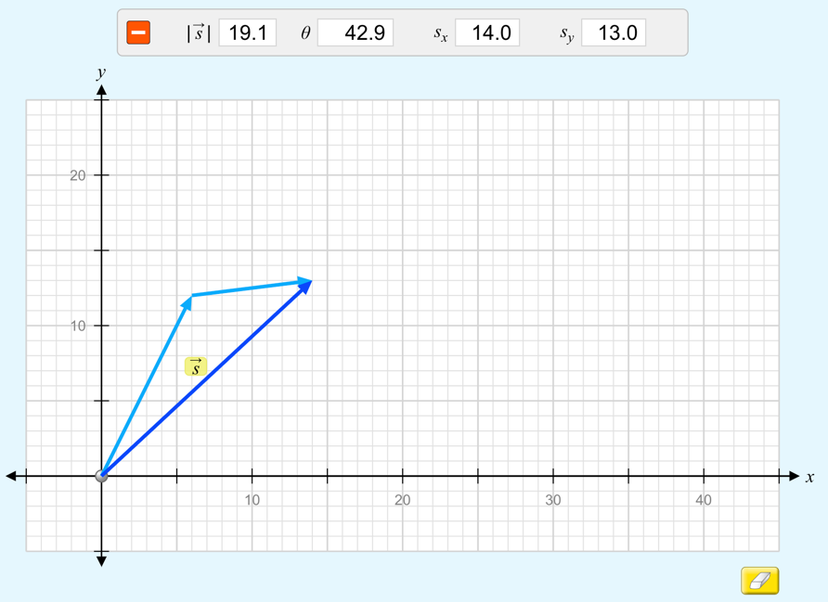

Figure 1: Case A’s vectors (cyan) plotted head to tail according to the polygon method. The vector components (shown above the graph) correspond to the vector sum (dark blue).

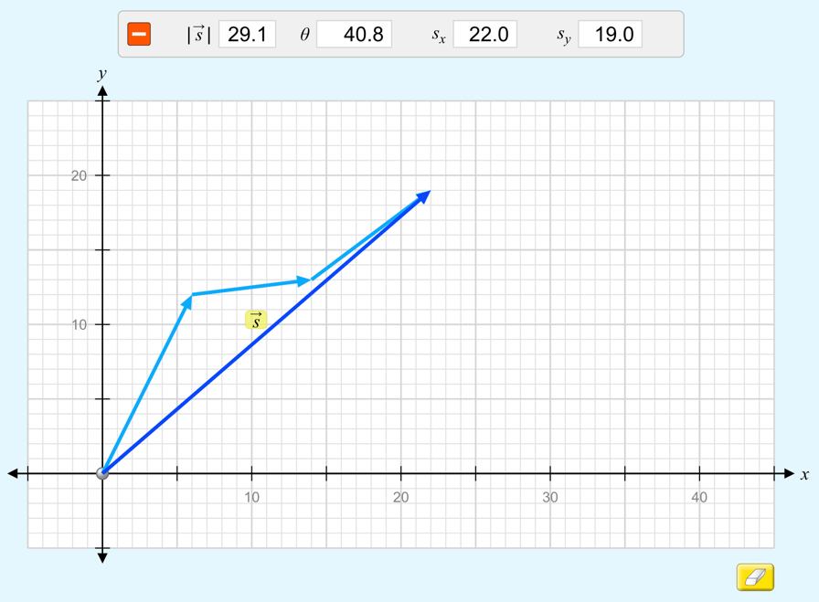

Figure 2: Case B’s vectors (cyan) plotted head to tail according to the polygon method. The vector components (shown above the graph) correspond to the vector sum (dark blue).

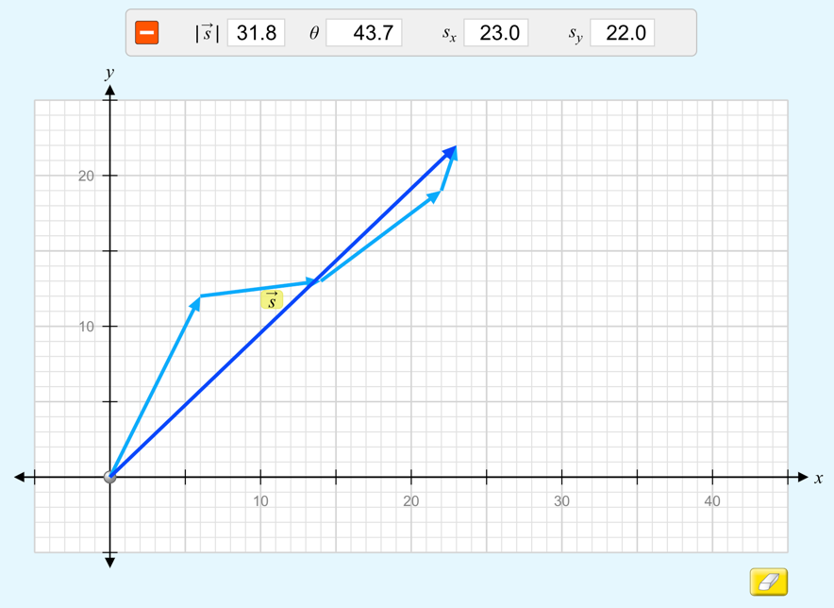

Figure 3: Case C’s vectors (cyan) plotted head to tail according to the polygon method. The vector components (shown above the graph) correspond to the vector sum (dark blue).

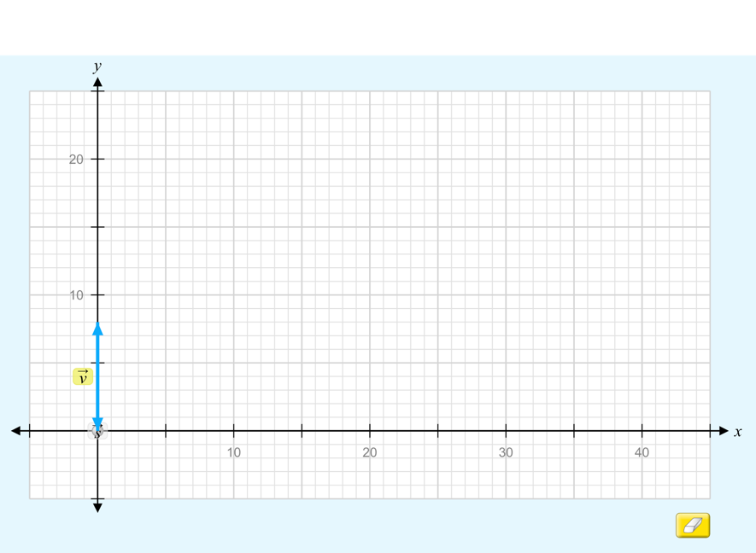

Figure 4: Case D’s vectors (cyan) plotted head to tail according to the polygon method. The vector sum is zero, so no other vector is shown.

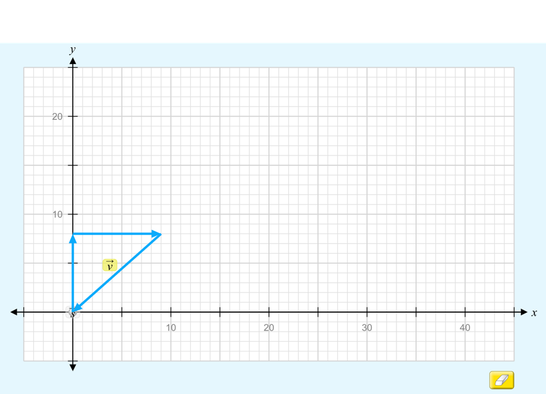

Figure 5: Case E’s vectors (cyan) plotted head to tail according to the polygon method. The vector sum is zero, so no other vector is shown.

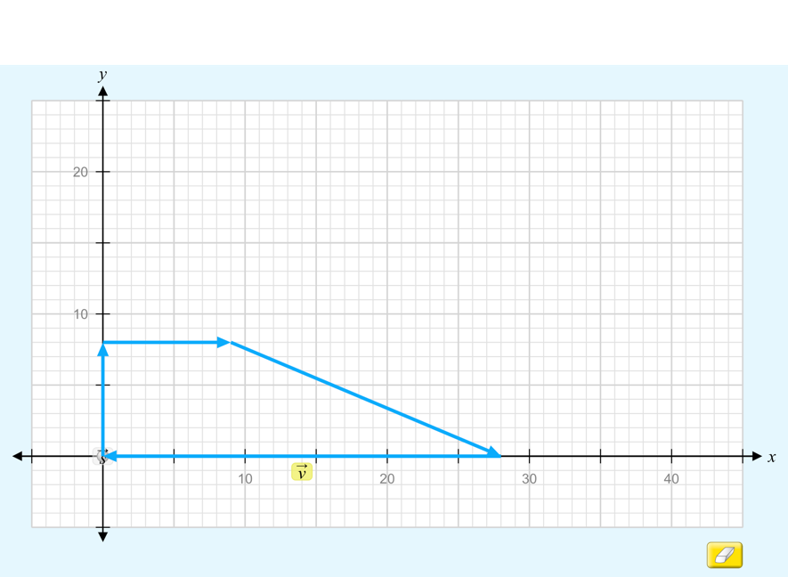

Figure 6: Case F’s vectors (cyan) plotted head to tail according to the polygon method. The vector sum is zero, so no other vector is shown.

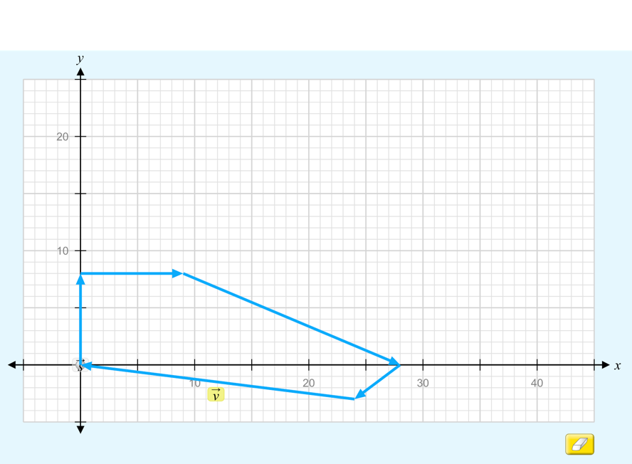

Figure 7: Case G’s vectors (cyan) plotted head to tail according to the polygon method. The vector sum is zero, so no other vector is shown.

Results

Though percent difference calculations aren’t shown for the sake of brevity, the average percent difference between all the values calculated and all the values obtained is below 1%. For a large majority of the calculations regarding the addition of vectors and vector components, the answer matched the obtained/theoretical value exactly.

Discussion/Conclusion

This experiment was designed to give insight into vectors and the addition of vectors. Using the formulas Ax = A(cosθ), Ay = A(sinθ), Rx = Ax + Bx + Cx + …, and Ry = Ay + By + Cy + …, the total sum of several vectors can be calculated. These calculations, taking into consideration how the values provided by simulation are limited in the digits they can display, introduce essentially no error. The results show how vectors have several components such as their x-component and y-component, and also how useful it is to break vectors down into their components.
There was almost no error in the simulation and experiment, which is understandable given the theoretical nature of the experiment. One thing to improve future experiments is to enable the simulation to display more digits to its values, in order to further reduce the error caused by rounding.

